Preparation of flexible zinc oxide/carbon nanofiber webs
for mid-temperature desulfurization

Hyo-Been Im¹, Soon-Jin Kwon¹, Han-Ik Joh², Sungho Lee^{2*} and Gildong Hong^{3*}

¹ Graduate School of Energy Science and Technology, Chungnam National University, 99 Daehak-ro,
Yuseong-gu, Daejeon 305-764, Korea
²Carbon Convergence Materials Research Center, Institute of Advanced Composite Materials, Korea Institute of Science and Technology, San 101, Eunha-ri, Bongdong-eup, Wanju-gun, Jeollabuk-do, 565-905,
Republic of Korea
³Department of Chemical Engineering Education, Chungnam National University, 99 Daehak-ro, Yuseong-gu, Daejeon, 305-764, Republic of Korea
^{*3} Corresponding author: Fax:82-42-821-8864, E-mail:xxxx32@ cnu.ac.kr

INTRODUCTION
Zinc oxide (ZnO) has been widely used to remove hydrogen sulfide (H₂S), which is one of toxic gases to degrade industrial facilities and pollute environment. The volatility of Zn at reducing environment over 600 °C has been known as a serious drawback so that the effort to reduce the reaction temperature using ZnO nanoparticles has been studied because they are much more reactive due to the increased surface area and enhanced gas diffusion characteristic. [1]
In this study, we report in-situ preparation of ZnO nanoparticles dispersed on nanofibers using simple and fast electrospinning for the application on H₂S adsorption. The mixtures of Zn precursors and polyacrylonitrile (PAN) in solvent were electrospun, and following heat treatment at 600 °C rendered ZnO/PAN nanofiber webs, which can be utilized as flexible adsorbents in various industrial applications.
EXPERIMENTAL
Materials
PAN and various amounts of zinc precursors were dissolved in DMF and stirred for 24 h at 60 °C to prepare four different mixing solutions containing 8 wt% of PAN and 23.1, 32.2, 40.3, 47.4,or 53.6 wt% of zinc precursors. As a reference, pure PAN solution was also prepared.
Characterizations
X-ray diffraction analysis (XRD, Smart Lab, Rigaku.) was performed with Cu K⍺ radiation and 2θ ranged from 10 to 80°.The surface areas of the absorbents were measured by nitrogen adsorption–desorption at 76K on an ASAP 2010 analyzer (Micrometics, USA). To evaluate the weight % of ZnO in composite samples after heat treatment, thermogravimetric analysis (TGA Q50, TA instrument) was carried out from 40 and 800 °C in O₂ atmosphere.
H₂S adsorption breakthrough tests
Dynamic breakthrough tests were conducted at 300 °C. 0.5 cm³ of the adsorbents diluted with 1.0 cm³ of Al₂O₃ (Sigma-Aldrich, ~150 mesh) for a total of 1.5 cm³ of bed were packed into a quartz tube (internal diameter 10 mm). In order to quantify the reactivity of ZnO with H₂S, sorbent utilizations were calculated as follows:
sorbent utilization (%)=T/T_{t} ×100 (2)
where, T is the experimental breakthrough time (min/g of ZnO), andT_{t} is the theoretical breakthrough time (min/g of ZnO), which can be obtained from Eq. (3).
(3)
RESULTS AND DISCUSSION
Thermal and structural properties of ZnO/CNF webs
TGA thermograms of carbonized pure and its composite nanofibers in N₂ atmosphere showed residue of 0, 13.6, 19.0, 25.7, 29.5, and 34.2% in weight, which is evident that Zn precursors changed to Zn or ZnO in nanofibers after mild carbonization at 600 °C (see Fig. 1).
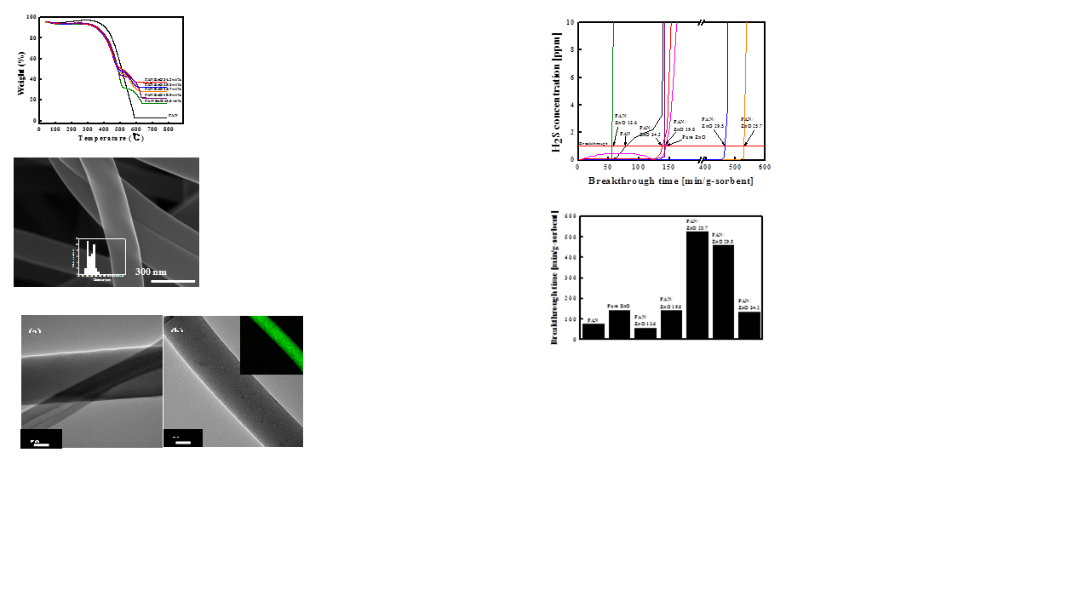

Fig. 1 TGA data of the ZnO contents
While a weight loss started at ~ 450 °C with carbonized pure PAN, carbonized composites decomposed at ~ 350 °C. It is worthy to note that carbonized nanofibers are flexible webs even though they have such a high content of ZnO up to 34.2 wt% .
Morphologies of ZnO/CNF samples
The morphology of heat-treated PAN nanofibers, containing nano-size ZnO in the range of 0.0-34.2 wt%, was observed by SEM micrographs shown in Figure 2; Pure CNFs with an average diameter of 140 nm presented smooth surface, and ZnCNF13 showed a similar morphology to pure CNFs (see Fig. 2). ZnCNF25, however, the bumpy morphology of nanofibers was observed with ZnO particles (~ 10 nm), which appeared on the surface of nanofibers. TEM micrograms clarify dispersed ZnO nanoparticles in nanofibers. The textural difference between pure CNF and ZnCNF13(see Fig. 3a and b), respectively, reveals a trace of ZnO nanoparticles as small dots. The inset in Figure 3b is a mapping result, indicating well dispersed of green ZnO nanoparticles.

Fig. 2 SEM image heat-treated nanofibers containing nona-size ZnO.

Fig. 3 TEM image of ZnCNF13
H₂S adsorption breakthrough tests
H₂S adsorption breakthrough time, as min per gram of adsorbent, depending on absorbent composition is presented (see Fig. 4 and Fig. 5).ZnCNF25 showed significantly increased breakthrough time of 530 min/g-sorbent that is almost 10-fold increase compared to that of ZnCNF13. The possible explanation for this phenomenon is as follows. When small amount of Zn precursors are in the electrospun fiber, nano-sized ZnO particles are formed via calcination keeping its original position in the fiber;

Fig. 4 H₂S concentration of samples

Fig. 5 Breakthough time of samples

CONCLUSION
We have found the desulfurization ability of ZnO/CNF webs is very sensitive to the contents of ZnO incorporated due to their morphologies and 25.7 wt% of ZnO incorporation in the CNFs led the best performance in desulfurization with showing 114% of absorbent utilization rate. Therefore, we believe that the electrospinning was a facile method to provide ZnO incoporated CNF webs as promising flexible H₂S adsorbents for mid-temperature H₂S removal.
REFERENCES

[1] H.S. Song, M.G. Park, E. Croiset, Z. Chen, S.C. Nam, H.J. Ryu, K.B. Yi, Applied Surface Science 280 (2013) 360-5.

